The University of Azad Jammu and Kashmir, Muzaffarabad

Name :Alishba Zakir
Roll No: 2024-SE-02
Course: Computer Networks
Course Code: SE-2203
Lab# 1
Submitted To: Engr. Dr. Asma Javaid
Submitted By: Alishba Zakir
Date : 3 Mar, 2026

Department Of Software Engineering

Installization of Cisco Packet Tracer
Step :1
First Step to Download Cisco Packet Tracer :
The first step is to search for Cisco Packet Tracer on Google, but make sure you download it from the official Cisco website



Step :2

Download Cisco Packet Tracer

In the second step, open your web browser and search for Cisco Packet Tracer for Windows. Go to the official website or a trusted source and click on the Download button. Make sure you select the correct version according to your operating system (Windows 64-bit). After clicking download, wait for the file to be saved on your computer. Once the download is complete, you are ready to install the software.

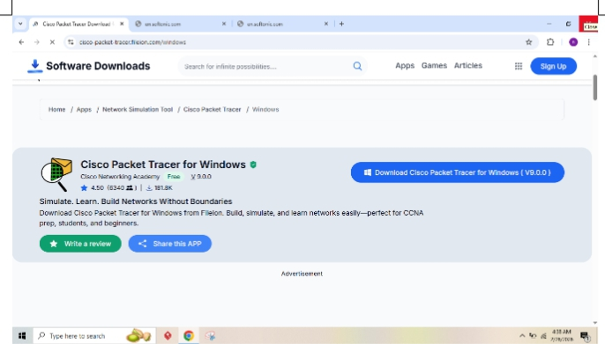

Step :3

In this step, review the installation details such as the destination folder and Start Menu location. If everything is correct, click on the Install button to begin the installation process. Wait for the setup to complete. You can click Back to make changes or Cancel to stop the installation.

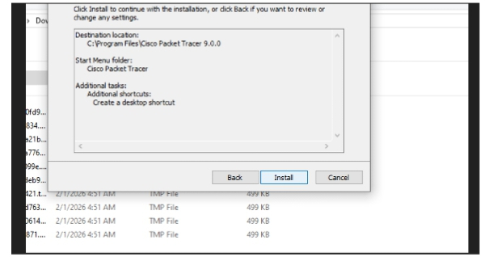
Step :4
Create/Log in to your account: Since you are at a login screen, you must have a free Cisco account. If you don't have one, click the option to sign up.

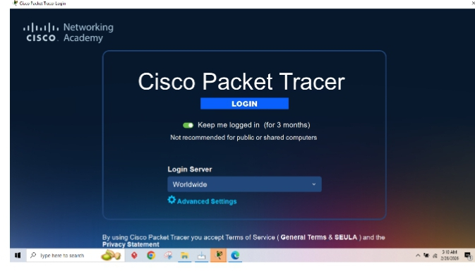
Step :5
You are now on the main "Logical" workspace. You can start building your network by dragging and dropping devices from the bottom toolbar onto the grid.

